Chapter 8

Location Decisions

**Background**

Presenting location strategies can be fun because students have certain opinions and passions about geography. Being careful not to offend, the instructor can insert humor or quirky characteristics about locations (cities, states, countries) into the examples discussed. An easy target would be the home town of the rival sports team.

The two company videos associated with this chapter are particularly interesting when both are shown to the class because insightful comparisons can be drawn. The Red Lobster description of its graphical information system (GIS) might be especially eye-opening for students.

A lot of the location factors are interesting and potentially controversial. Discussion about any of those can carry on for some time.

Low labor costs often represent a major reason why companies (especially manufacturing firms) locate in particular countries. It may be useful to have a slide handy that compares hourly wage rates across certain countries, including the U.S., Germany, Japan, Mexico, and certain low-wage Asian countries.

**Class Discussion Ideas**

1. Prior to showing any presentation slides, instructors can solicit 5-20 minutes of student input by asking the simple question, “Can you identify the factors that should be considered when making a global facility location decision?” There are literally dozens of possible contributions, which might be summarized into categories of (1) Site Costs, (2) Environment/Economy, (3) Basic Services, (4) Labor and Staff Availability, (5) Accessibility, and (6) Government, Legal Issues, Taxes, and Incentives.

2. As the world’s largest retailer, Wal-Mart has plenty of fans as well as detractors. A Wal-Mart discussion can begin by asking the students how the firm became so successful when it was a late mover in the discount retail market. Sam Walton made the (what now seems) simple realization that people living in rural areas need basic living products too, and that such markets were being completely ignored by other retail chains. So rather than competing in big cities, almost all of Wal-Mart’s early expansion activities were in small to medium-sized markets. Now the company is trying to do the same thing overseas. This could lead to the question of how small of a market is still “big enough” to support a store like Wal-Mart. What about a grocery store? What about a fine dining restaurant? What about an oil change shop? Finally, there are areas of the country that have opposed Wal-Mart’s efforts to open a store. Why is there such opposition when Wal-Mart provides jobs, tax revenue, lower prices, and significant local charitable giving? When faced with such opposition, how should Wal-Mart react? For such a large firm that has extremely loyal customers in some parts of the country, is it worth it for Wal-Mart to fight legal battles in every small town that opposes its presence?

**Active Classroom Learning Exercises**

1. Exchange Rate and Political Risk Exercise: Exchange rates and political risk are identified in this chapter as important country decision factors. The concept of operational hedging is explained in the “Other Supplementary Material” section for Supplement S7 of this manual. Instructors might divide the class into groups and set up an exercise where each group can choose to build plants in certain countries and choose the amount of excess capacity (if any) to have at each plant. Then a simulation of, say, five to ten time periods can be run where the exchange rates change significantly each time (these can be generated randomly or be pre-chosen by the instructor). After each exchange rate realization, profit for each group can be calculated. Then before the next exchange rate realization, the groups have the option of reallocating production and distribution levels using their excess capacity or choosing the more expensive option of closing and opening new plants. If computers are available, this exercise can be automated and can incorporate the transportation model using pre-made Excel spreadsheets provided by the instructor. Extra credit points might be awarded to well performing teams. In general, groups that apply smart operational hedging strategies should outperform those who do not employ any excess capacity, unless the latter groups get lucky with their exchange rate predictions. To spice things up, the instructor could even introduce a political risk component, whereby in each period certain countries have a chance to nationalize all of the firm’s assets.

2. Choose several local and national organizations familiar to the students and have them choose a location decision methodology appropriate for each organization. This is a good way to illustrate differences between the methodologies and evaluate when each methodology might be most appropriate.

**Company Videos**

*1. Locating the Next Red Lobster Restaurant (10:47)*

Red Lobster has 650 locations in the U.S. and Canada, and the firm is always looking at “where to grow next?” The firm examines trade area characteristics, site characteristics, and real estate characteristics. Trade area characteristics include a number of demographic factors, such as income, population density, racial composition, average age, competition, nearby hotels and freeways, and buying behavior. Site characteristics include items such as parking, signage, visibility, and ingress/egress. Technology has automated the trade area definitions to be provided in just minutes. The video shows several shots of computer screens utilizing this software. Darden has partnered with MapInfo’s Graphical Information System (GIS) to obtain demographic information down to the street level, providing psychographic profiles for potential locations. MapInfo defines households by clusters based on income and buying behavior. Red Lobster scores each cluster from 20 (representing 1/5 the value of a standard customer) to 200 (representing twice the value of a standard customer). The software allows Red Lobster to search by sales volume, maximum cannibalization of existing locations, and minimum distance from existing locations. It will also recognize the nearness of the competition. Even after approving a new restaurant location, two years typically pass before the restaurant is built and ready to open doors.

Prior to showing the video, instructors might ask students to think about the last Red Lobster (or similar) restaurant in which they ate. Where was it located and why? Discussion following the video could go over some of these and compare with the factors that seemed to be important to Red Lobster. The discussion could then move to issues of using demographic data to choose locations. How can a chain like Red Lobster gather the information to know the sales impact for each of the cluster types? Does the organization need to interview actual customers, send out surveys, or perhaps conduct phone interviews? And is the firm sure that a cluster will have the same sales impact in one part of the country as it does in another? Finally, the video only glossed over the issue of competition, but competition can have both positive and negative effects on restaurant sales. Research has shown that when several restaurants locate near each other, total customer volume over all those restaurants is greater than it would be if the restaurants were located far apart. (In other words, customers want to go out to eat, so they drive to the location with many good choices—the same concept applies with food courts in shopping malls.) So should Red Lobster be looking to locate near its competition? Why or why not? Also, what if the choice comes down to two cities with similar demographics? City A has, say, 6 similar restaurants while City B has, say, 3 similar restaurants. Is the answer definitely that Red Lobster should locate in City B? Do customers have a fixed number of times that they will eat out per month, or may that number vary if there are more choices?

2. *Where to Place the Hard Rock Café (8:36)*

As with Red Lobster restaurants, Hard Rock Cafés comprise a restaurant chain, but this video has a different feel from the Red Lobster location video. The Senior Director for Worldwide Café Development has a significant amount of personal authority to determine future locations, and the priorities for Hard Rock seem to be a bit different than for Red Lobster. Although the firm certainly performs a significant amount of analysis, the Hard Rock approach seems to be somewhat less scientific than Red Lobster’s and based partly on a “feeling” for the right city to go to and the right part of town in which to locate. The firm also carefully considers how the city is evolving and what it might look like in 10-15 years, because the leases are usually signed for that length of time. For Hard Rock, location begins with a global view of which country to go into (the U.S. market seems to be fairly well saturated from Hard Rock’s point of view). Hard Rock considers country factors such as political risk, currency risk, social norms, brand fit, social costs, and business practices. After good potential countries are identified, Hard Rock then focuses on regions, followed by cities. Important city factors include population, disposable income, visitor income, and whether it would be good to locate in the city center (which Hard Rock usually prefers) or the suburbs. Once potential cities are identified, Hard Rock performs breakeven analysis to determine if purchase and construction or remodel will be profitable.

Prior to showing the video, instructors might ask the students if they have eaten at any Hard Rock Cafés, and, if so, in what part of the city were they located? Was the location chosen primarily to attract tourists or local residents? Following the video, discussion might try to compare the factors that are important for Hard Rock with the students’ perception of another well-known international restaurant chain: McDonald’s. Would a McDonald’s typically be located next to a Hard Rock? If not, why not? A different discussion stream could focus on Hard Rock’s list of country factors. Under what circumstances do the students think that political risk might play a factor? Also, what did the Senior Director mean by “social costs?”

**Cinematic Ticklers**

1. *Wayne’s World (Mike Myers and Dana Carvey), Paramount Pictures, 1992*

During their TV program, Wayne and Garth take a video tour of various locations, and when they stop at Delaware, they have nothing to say.

**Presentation Slides**

INTRODUCTION (8-1 through 8-8)

Slide 8-8: Federal Express certainly represents a true American success story, beginning with an idea about overnight package delivery that few people thought (1) would be feasible, and (2) customers would pay for. A key reason why it works is the use of a central hub system, and this slide describes the benefits. Instructors can expand on this slide in a couple of ways. First, why did FedEx choose Memphis instead of any other U.S. city? The firm was promising unprecedented speed, but that speed would be meaningless unless FedEx could deliver on its promise consistently. For speed, the firm needed a city in a central location in the U.S. For reliability, it needed a city with few weather delays, which eliminates other potential locations such as St. Louis, Chicago, Minneapolis, and Kansas City. Second, what are the alternatives to a central hub system? Presumably, the two most likely alternatives would be: (1) flying a separate plane from each source airport to each destination airport, or (2) flying one plane from each source airport but sending that plane to each destination airport. Assuming *n* sources and destinations and keeping in mind that packages must arrive at the addressee’s door the following day, compared to a central hub system option (1) would require *n*2 planes vs. *n* planes, while option (2) would only require *n* planes but each would have to take off and land at all destinations before morning and the packages would have to be handled very carefully so they weren’t left at the wrong city. Such a discussion might be even more illuminating by picking, say five real cities and drawing plane routes on the board.



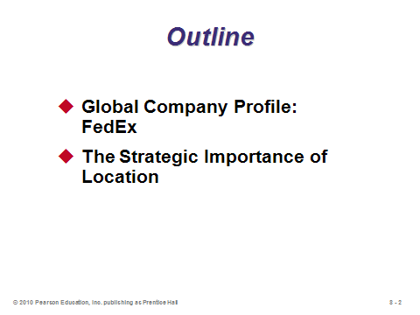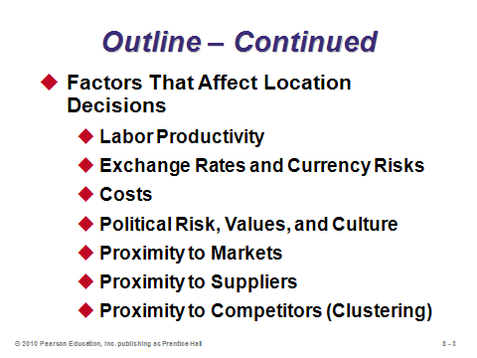

**8-1 8-2 8-3**

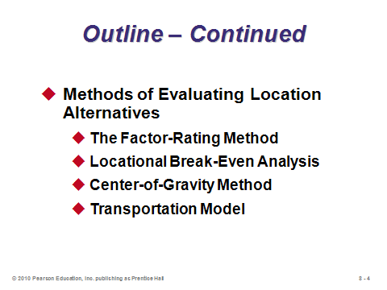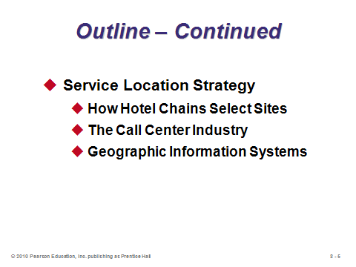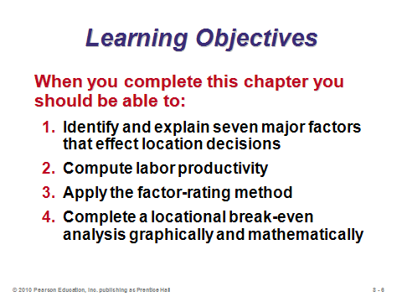

**8-4 8-5 8-6**

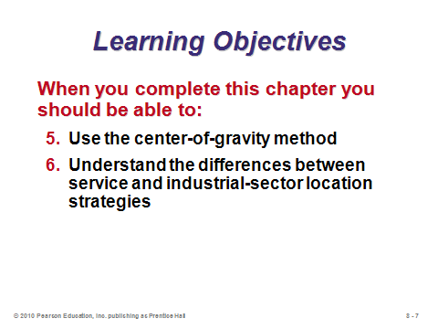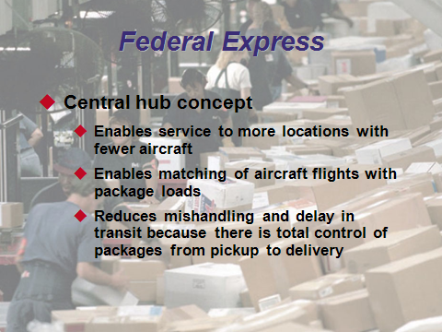

**8-7 8-8**

THE STRATEGIC IMPORTANCE OF LOCATION (8-9 through 8-12)

Slide 10: Instructors can use this slide to emphasize the importance of a quality location decision. Globalization has added options, but with more options comes a more complicated decision process. Location decisions are typically long-term in nature and can have a huge impact on both revenue and cost.

Slide 11: Location-related costs, such as utility and local labor costs, are often out of the firm’s direct control, so it is somewhat locked into dealing with these cost levels once the location decision is made.

Slide 12: If a firm is interested in locating in a place that will produce creativity and innovation, then cost-related factors may take a back seat. This slide identifies four attributes that seem to affect overall competitiveness and innovation when innovation is the focus of the location decision.

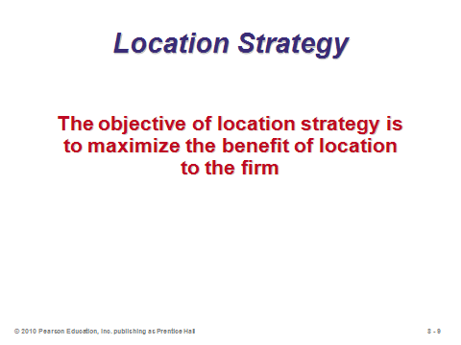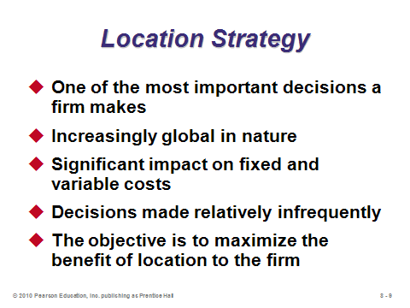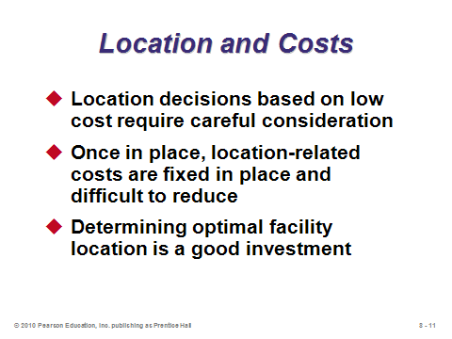

**8-9 8-10 8-11**

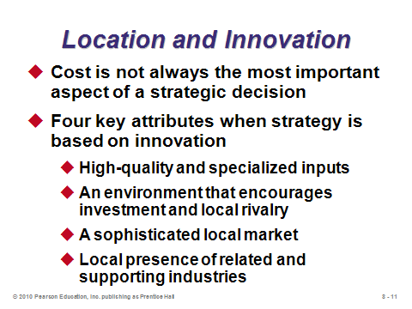

**8-12**

FACTORS THAT AFFECT LOCATION DECISIONS (8-13 through 8-27)

Slides 14-16: As exemplified by the Hard Rock Cafe video associated with Chapter 8, firms often divide their location decisions into three levels: first choosing a country, then a region, then finally a specific site. Slides 14-16 identify key factors that may arise for each of the levels.

Slide 17: Based on country success factors such as those identified in Slide 14, as well as certain negative factors such as crime, the World Economic Forum biannually ranks the global competitiveness of 134 countries.

Slide 18: Productivity differences among locations (which may be due to system or infrastructure factors, or possibly differences in the workers themselves) need to be considered when comparing costs. This slide provides a simple example of a higher wage rate location actually being cheaper overall due to productivity differences.

Slides 19-24: These slides cover some of the key success factors in more detail. Exchange rates are mentioned in Slide 19. Students understand that these vary over time, but they are often mistaken in believing that exchange rate movements can be predicted with any accuracy. (If anyone could, then that person should be making millions of dollars speculating in the currency markets and not spending time reading this chapter.) For example, just because the dollar has been falling in value over the past several months compared to, say, the euro, gives no indication of what will happen next. Thus, it’s dangerous to make future cost predictions based on exchange rates that are any different than the current ones. Instructors could take time here to talk about *managing* exchange rate risk by using either financial hedging (options) or operational hedging (excess capacity in different locations that is called upon when exchange rates shift). Slide 20 is emphasizing, in particular, that when firms jump around the world chasing the lowest costs, they may create hardship on their most recent geographical “tenants.” Also, some locations are low cost because they have few environmental regulations, but should a firm intentionally go somewhere so that it can pollute more? When viewing Slide 21, instructors might mention that it is possible to purchase political risk insurance. Firms that wish to avoid the possibility of corruption might be interested in country corruption rankings such as those provided by Transparency International (Slide 22). Slides 23-24 illustrate that sometimes desired proximity (to markets, suppliers, or even competitors) drives the location decision. Access to a significant resource pool (labor, raw materials, etc.) often drives competitors to locate near one another (Slide 24). But competitors sometimes cluster for marketing purposes instead. For example, in the restaurant world, studies have shown that more total customers will visit restaurants that are located near each other than would if they are not. Presumably, all restaurants get a piece of this bigger customer pie.

Slides 25-27: These slides provide excellent examples of clustering of competitors, and they are clustered for some very different reasons.

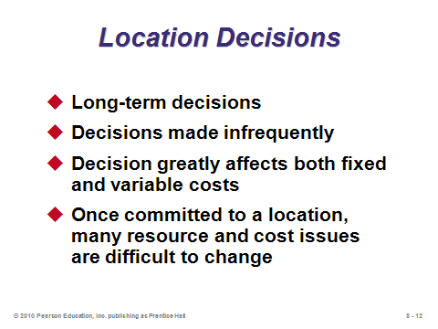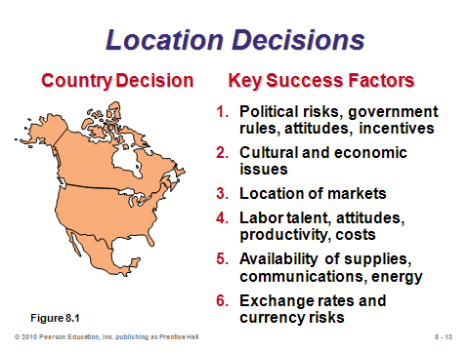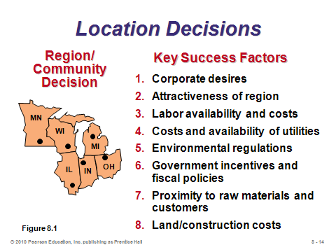

**8-13 8-14 8-15**

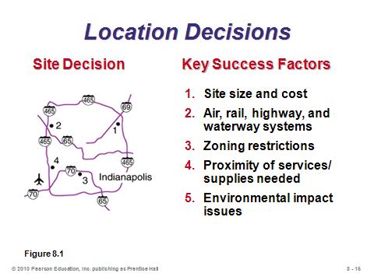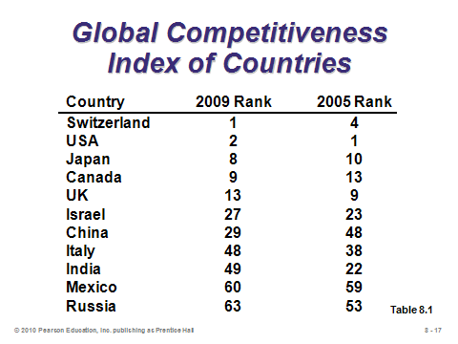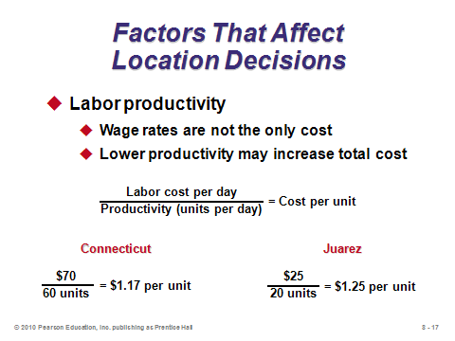

**8-16 8-17 8-18**

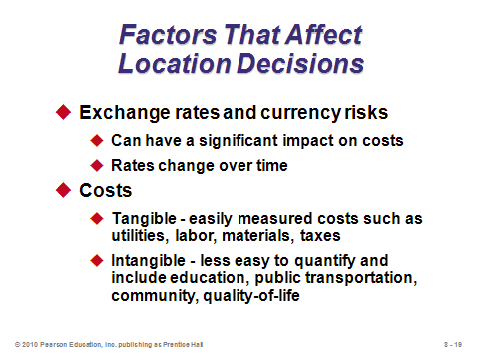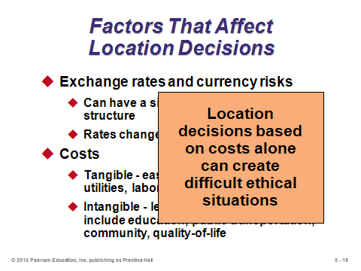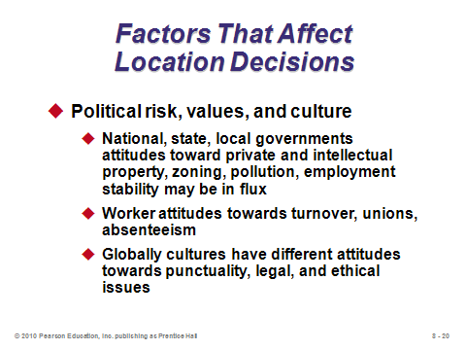

**8-19 8-20 8-21**

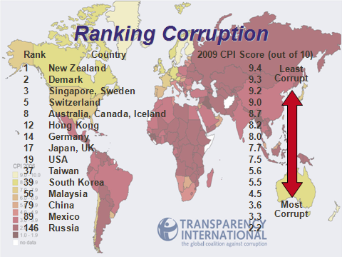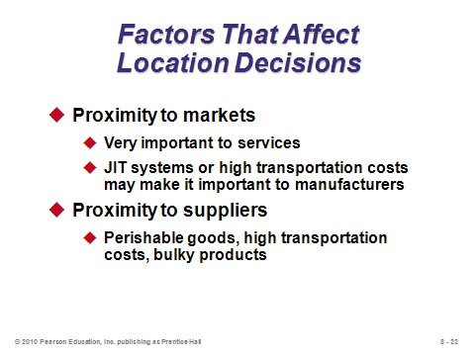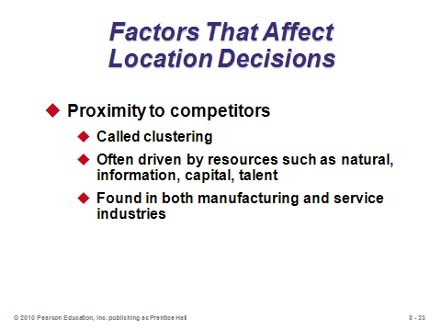

**8-22 8-23 8-24**

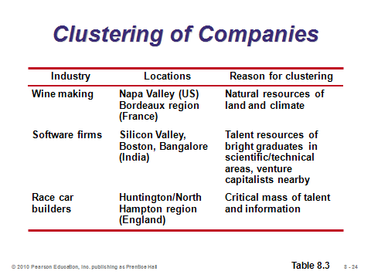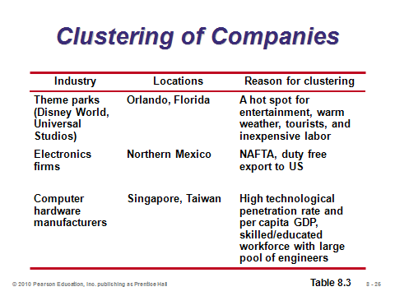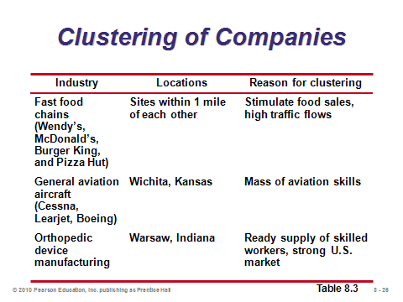

**8-25 8-26 8-27**

METHODS OF EVALUATING LOCATION ALTERNATIVES (8-28 through 8-40)

Slides 28-29: These slides describe the factor-rating method, which is used by many companies in the real world. It represents an attempt to convert qualitative factors into a numbers that can be analyzed. As the example in Slide 29 clearly shows, the method represents a simple weighted average approach. Instructors should point out some inherent dangers. While the approach appears to be objective in nature, it contains several subjective elements. For example, the weights themselves are subjectively chosen, and the actual location score for each factor may involve significant individual judgment as well. Raters should be careful—for example, when one location has a score of 80 and second has a score of 40, is the second location really 50% worse on that factor than the first location? And does 50% worse on one factor mean the same thing as 50% worse on another factor? Manipulators can play tricks with such methods by, for example, only including factors that are favorable for their favorite location or by including a bogus site that is so much worse on a particular factor (say, one that the manipulator’s favorite location performs poorly on) that the scores for all of the other locations end up being too close together in order to create the appropriate distance in score from the bogus location. Nevertheless, despite potential abuses and shortcomings, the factor-rating method can lead to thorough analysis and insight of many factors that should go into a proper location decision, and it can provide and objective-looking analysis to back up the final decision.

Slides 30-32: These slides describe and illustrate locational break-even analysis, which can be useful when comparing locations with clear fixed and linear variable production costs. The technique is the same idea as crossover analysis applied in Chapter 7 to process choice decisions.

Slides 33-38: These slides provide the formulas and a detailed example for the center-of-gravity method, used to find the weighted-average midpoint among a set of destinations to be served. Such methods are particularly useful for warehouses and distribution centers, or any locations either receiving from disperse sources or shipping to disperse customers. The method assumes Euclidean (straight-line) travel. Weights can be based on total volume shipped or shipping cost (total volume times each unit’s shipping cost per mile). Note that the actual center of gravity could place the facility in an undesirable location such as a volcano or the ocean. Typically, once the center of gravity is determined, a follow-up load-distance analysis of actual possible locations near the true center of gravity might be conducted. Two notes about the calculations: (1) the optimal *x* and *y* coordinates are computed separately, but they share the same denominator (the sum of the weights), and (2) calculations can be simplified by expressing weights, say, in thousands (for Slide 37)—since the numerator and the denominator can both be divided by 1000, the answers will be the same.

Slides 39-40: These slides examine the transportation model, which is described briefly in the text. This is also referred to as the allocation problem in the literature. Production-allocation decisions can change from period to period as production or transportation cost, plant capacity, and demand conditions change. The transportation model is one of the classic linear programming applications. Relatively large problems can be solved using Excel’s Solver add-in. Interested instructors could even create some *n* ×*m* transportation model templates to provide the students so all that the students would have to do is enter plant capacities, demands, and to-from costs, then invoke Solver to produce the optimal solution.

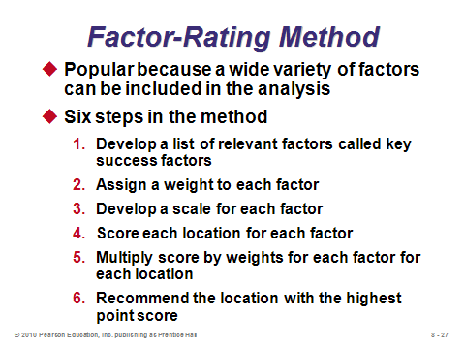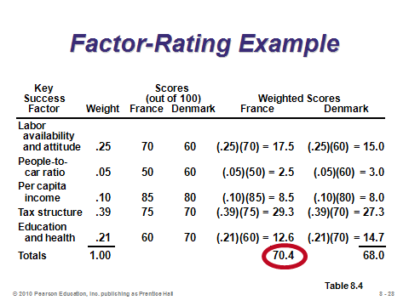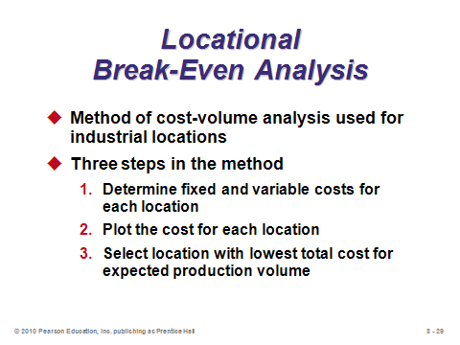

**8-28 8-29 8-30**

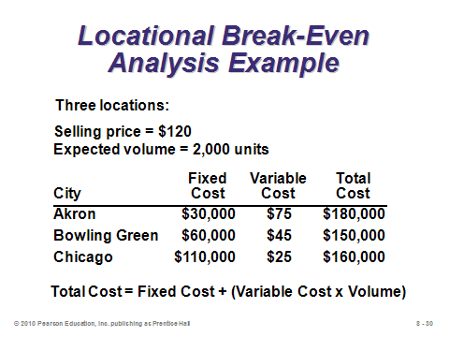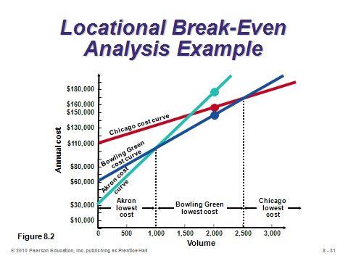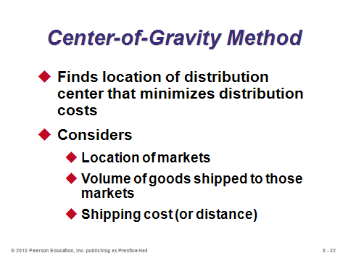

**8-31 8-32 8-33**

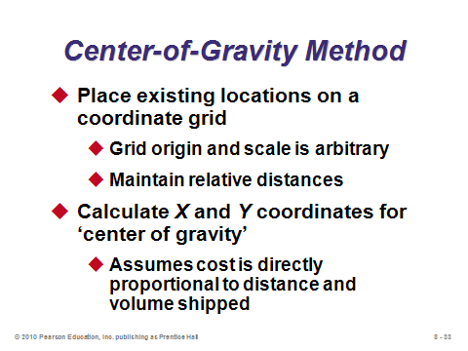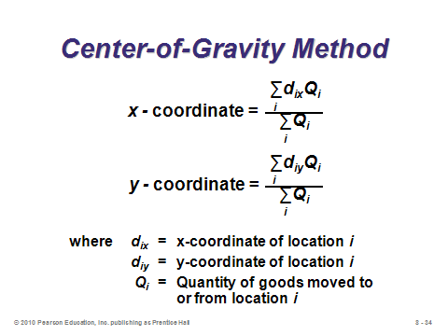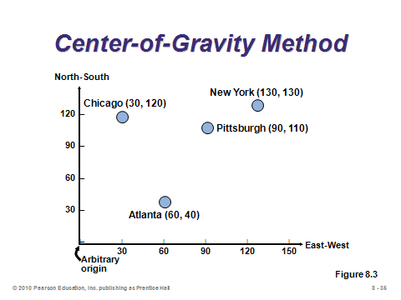

**8-34 8-35 8-36**

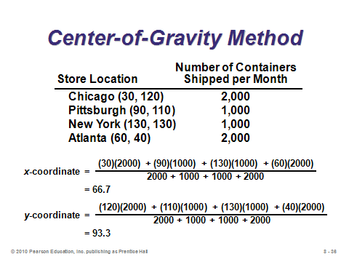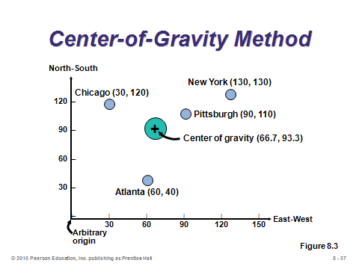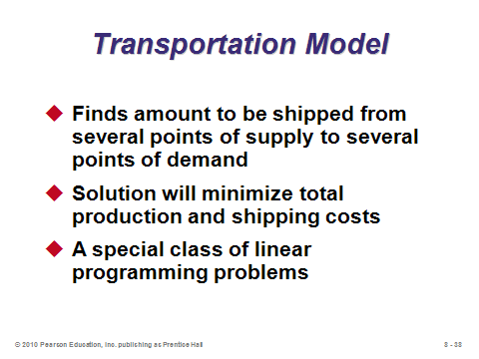

**8-37 8-38 8-39**

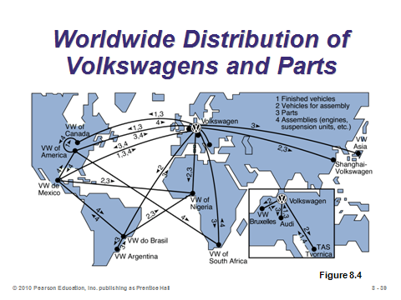

**8-40**

SERVICE LOCATION STRATEGY (8-41 through 8-48)

Slide 41: This slide identifies the eight major determinants of volume and revenue for the service firm.

Slides 42-44: These slides reproduce Table 8.6 from the text, which differentiates the location strategies and decisions between service and manufacturing firms. As the authors state, “Almost every aspect of the decision is different.”

Slide 45: This slide describes La Quinta’s regression model for location analysis. Most of the predictive power of profitability (the dependent variable) is contained in just four variables: (1) price of the inn, (2) median income levels, (3) state population per inn, and (4) location of nearby colleges. La Quinta then used the regression model to predict profitability and developed a cutoff that gave the best results for predicting success or failure of a site. A spreadsheet is now used to implement the model, which applies the decision rule and suggests “build” or “don’t build.”

Slide 46: Many service and manufacturing companies operate call centers. Factors important for the location decision of call centers are identified in this slide.

Slides 47-48: These two slides describe and illustrate geographic information systems (GIS), which are marvelous detailed informational tools of particular use for companies in a constant growth mode. The text provides several interesting GIS applications, and the Chapter 8 video, “Locating the Next Red Lobster Restaurant,” provides an excellent description of how the firm makes regular use of GIS to aid its location decisions for new restaurants.

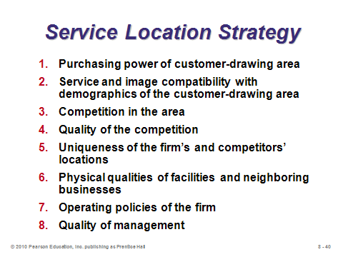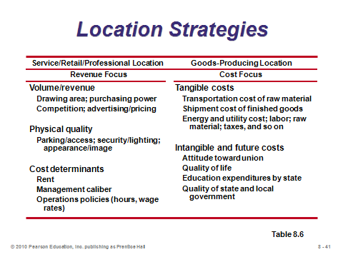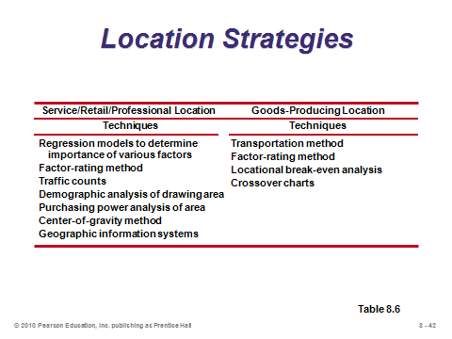

**8-41 8-42 8-43**

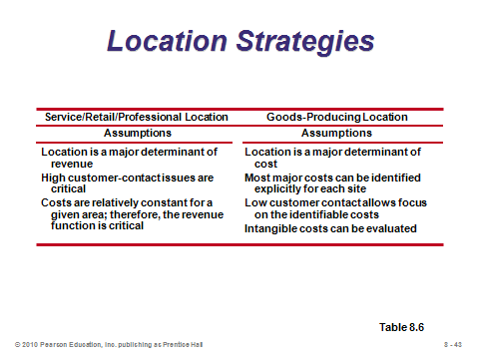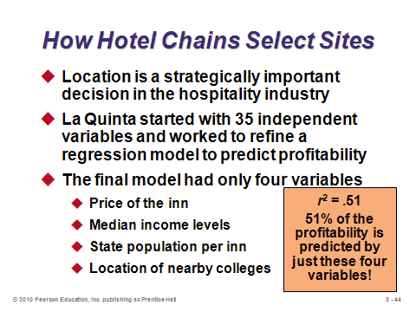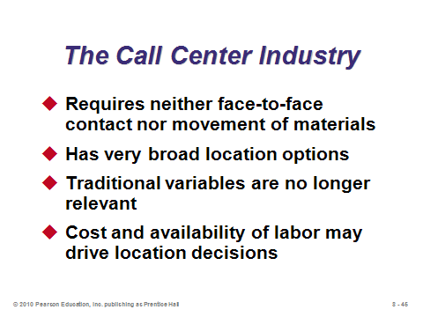

**8-44 8-45 8-46**

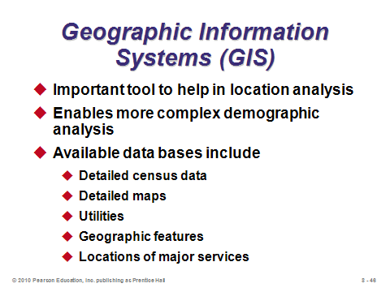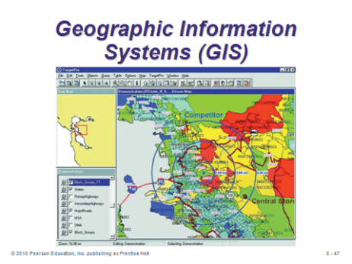

**8-47 8-48**

**Additional Assignment Ideas**

1. Visit the Web sites below and identify what services these firms and subsidiaries provide. How do the criteria they use compare with methods in the textbook?

www.conway.com

www.sitelocationassistance.com

1. Visit the online magazine *Site Selection*. Read and summarize an article relating to this chapter. Provide a printout of the article with your summary.

http://www.siteselection.com

1. Imagine you are a manager in a multinational firm considering expanding in Europe. One area seeking to attract your business is Wallonia, Belgium. What are some advantages and disadvantages of locating in Wallonia? What are the locals called?

Hint: you might visit http://www.wallonie.be/en/home.shtml

**Additional Case Studies**

Internet Case Study (www.pearsonglobaleditions.com/heizer)

* *Southwestern University's Location Decision (E)*: The University faces three choices in where to locate its football stadium.

Harvard Case Studies (http://harvardbusinessonline.hbsp.harvard.edu)

* *Filene's Basement* (#594-0418): This retailer is trying to decide where to add two new stores in its Chicago operation.
* *To Move or Not to Move: Cathay Pacific Airlines* (#HKU-003): Should this airline relocate its data center from Hong Kong to a new country?
* *Wriston Manufacturing* (#698-049): An auto parts producer is trying to decide whether to close one of its Detroit plants.
* *Ellis Manufacturing* (#682-103): This kitchen appliance manufacturer has duplication of resources in its plants.

Richard Ivey School of Business (http://cases.ivey.uwo.ca/cases/pages/home.aspx)

* *Whitewater West Industries Limited* (#9A96D005): The president has to decide where to relocate his water park manufacturing company's production facility. Not only has the company apparently outgrown its current site, but residents near it have complained about unpleasant odors. The company has investigated three potential sites that students have to evaluate both financially as well as from a strategic point of view: should the company own or rent its facility?
* *Blackshop Bistro* (#9A93D029): The son of the founder and owner of Blackshop Bistro had to decide how to respond to his father's suggestion that the family business relocate to a new commercial building nearby. The fine-dining restaurant had enjoyed great success; however, to achieve its growth objectives and offer the founder's sons an opportunity, the business must seek alternatives to expand sales. Expansion may ultimately threaten the Bistro's current strategy and target market.

**Internet Resources**

|  |  |
| --- | --- |
| Economic Development Service | www.sitelocationassistance.com |
| Location Strategies | locationstrategies.com |
| National Association of Manufacturers | www.nam.org |
| *Site Selection* Magazine | www.conway.com |
| Transparency International, which maintains a bribe payers perception index (BPI) and a corruption perception index. | www.transparency.org |

**Other Supplementary Material**

Commercial Software

* ESRI, GIS and mapping software and data sets.

ESRI

380 New York Street.

Redlands, CA 92373 8100

(P): 909-793-2853

Web site: http://www.esri.com

Quick Estimate of Potential Market Penetration

A *Fortune Magazine* article from 1994 describes Cantalupo’s Theorem, which is a back-of-the-envelope calculation used to estimate the potential penetration of McDonald’s in any specific country. The formula is:



The calculation includes some interesting assumptions, such as being richer will tend to cause one to eat *more* at McDonald’s (probably true in poor countries—may not be true in rich countries) and also that the desire to eat at McDonald’s per person is the same in different cultures around the world. Nevertheless, the calculation does allow for a quick comparison of actual to potential (as defined in the formula). We updated selected country results based on 2004 data (using 21,810 people per McDonald’s in the U.S. and a U.S. per capita income of $39,453). The results are shown below. It looks like there is a lot of potential room for growth in many countries. The market potential numbers for the two most populated countries, India and China, are particularly interesting.

|  |  |  |
| --- | --- | --- |
| **Countries** | **Current Number of Restaurants** | **Minimum Market Potential** |
| Japan | 3,774 | 5,401 |
| Canada | 1,362 | 1,120 |
| Britain | 1,248 | 2,456 |
| Germany | 1,262 | 3,164 |
| Australia | 729 | 736 |
| France | 1,034 | 2,321 |
| Fiji | 3 | 3 |
| South Korea | 337 | 777 |
| China | 639 | 1,931 |
| Russia | 127 | 676 |
| Colombia | 27 | 120 |
| India | 67 | 821 |
| Pakistan | 18 | 109 |
| South Africa | 89 | 265 |

Load-Distance Model

To supplement the center-of-gravity method material, instructors could introduce the load-distance method. It is a simple way to compare total distance-related costs among a *choice* of locations (recall that the center-of-gravity method provides the *unconstrained* optimal location). The method is quite simple. Calculate the load-distance score *ldi* for each candidate location *i*, and choose the location with the lowest score. The formula is *ldi* = Σ*i* *lijdij*, where *lij* is the load between facility *i* and customer *j*, and *dij* is the distance between *i* and *j*.